Narra Gopi chand
Registration no: 192371093
C PROGRAM – COMMENT REMOVAL

Program Code
#include <stdio.h>
int main()
{
char c, next;
while ((c = getchar()) != EOF)
{
if (c == '/')
{
next = getchar();
if (next == '/')
{
while ((c = getchar()) != '\n' && c != EOF);
}
else if (next == '*')
{
while ((c = getchar()) != EOF)
{
if (c == '*' && (next = getchar()) == '/')
break;
}
}
else
{
putchar(c);
putchar(next);
}
}
else
{
putchar(c);
}
}
return 0;
}

Output Screenshot
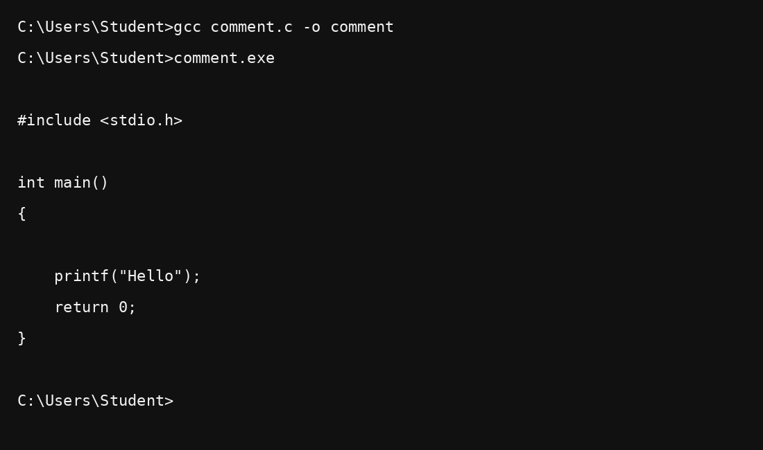
Result: Comments were successfully removed from the C program.

